Instructor Guide
Module 3

INTERNAL COMPLAINT RESOLUTION,
REFUSAL TO WORK,
PREGNANT AND NURSING MOTHER PROVISIONS

INTRODUCTION - COMPLAINT RESOLUTION PROCESSES 3
1. INTERNAL COMPLAINT RESOLUTION PROCESS (ICRP) 4
1.1 GENERAL 4
1.2 HOW THE PROCESS WORKS 4
2. REFUSAL TO WORK 7
2.1 DEFINITIONS 7
2.2 THE RIGHT TO REFUSE DANGEROUS WORK 7
2.3 SPECIAL NOTE – REPAYMENT 10
3 PREGNANT AND NURSING EMPLOYEES 13
4. REFERENCES & ACKNOWLEDGEMENTS: 14

Version: Draft 1.1

Module 3 - INTERNAL COMPLAINT RESOLUTION,

REFUSAL TO WORK

AND PREGNANT AND NURSING MOTHER PROVISIONS

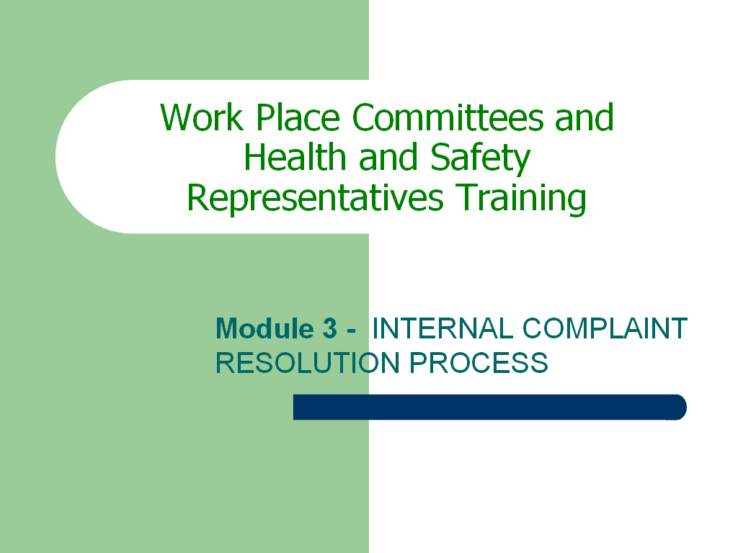  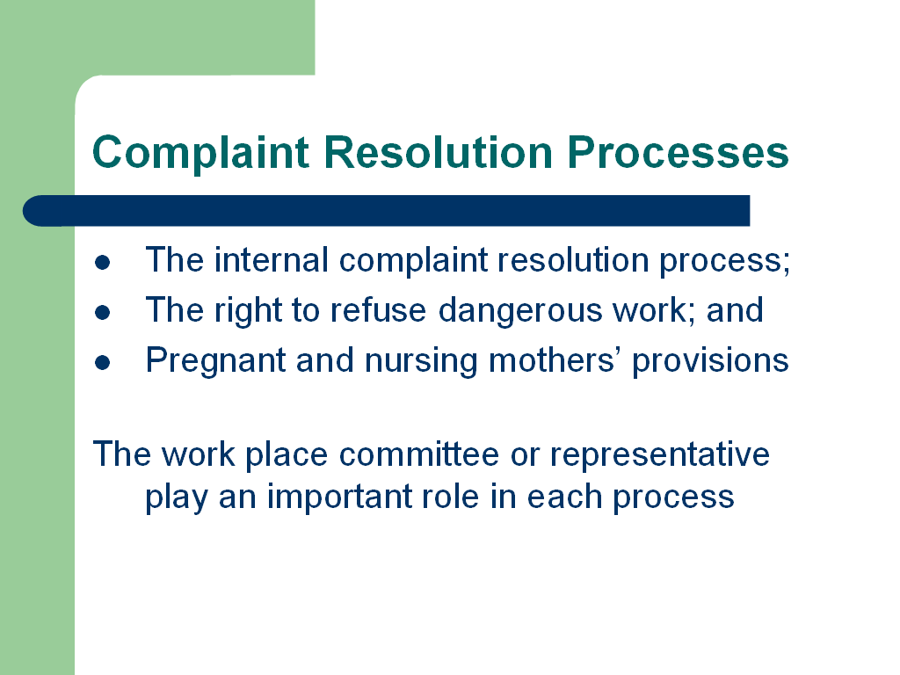 | INTRODUCTION - COMPLAINT RESOLUTION PROCESSES  The Canada Labour Code Part II contains three specific complaint resolution processes to ensure that employees are able to protect and exercise their right to a safe and health work place:  - The internal complaint resolution process;  - The right to refuse dangerous work; and  - Pregnant and nursing mothers’ provisions  In each process, a specific procedure is detailed that must be followed by each party. A manager who fails to follow the processes as detailed in the Canada Labour Code may create a situation of non-compliance for the employer. An employee who fails to follow the procedures may lose the protections against reprisals normally afforded employees exercising their rights under the Canada Labour Code Part II. Thus, it is important that all staff understand these procedures and follow them in accordance with specifications.  The work place committee plays an important role in each of the complaint resolution processes, not least of which is providing counsel to those involved in the process. Work place committees and representatives are often relied upon by both management and unions alike to assist in understanding and applying the requirements specified by law. The law also provides for them to take an active role in these proceedings as detailed below.

1. INTERNAL COMPLAINT RESOLUTION PROCESS (ICRP)

1.1 GENERAL
This process is in keeping with past emphasis on the internal responsibility system; that is, allowing the workplace parties to resolve issues and develop solutions to matters involving health and safety. This process in no way affects an employee’s right to refuse dangerous work. The process provides the employer/supervisor with the opportunity to address and correct employee concerns without the need to involve the work place committee or a health and safety officer from HRSDC.
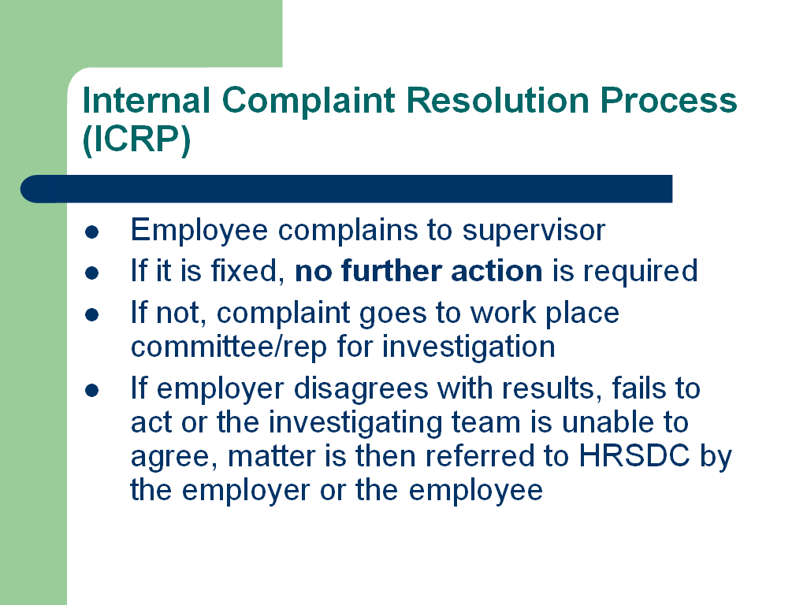  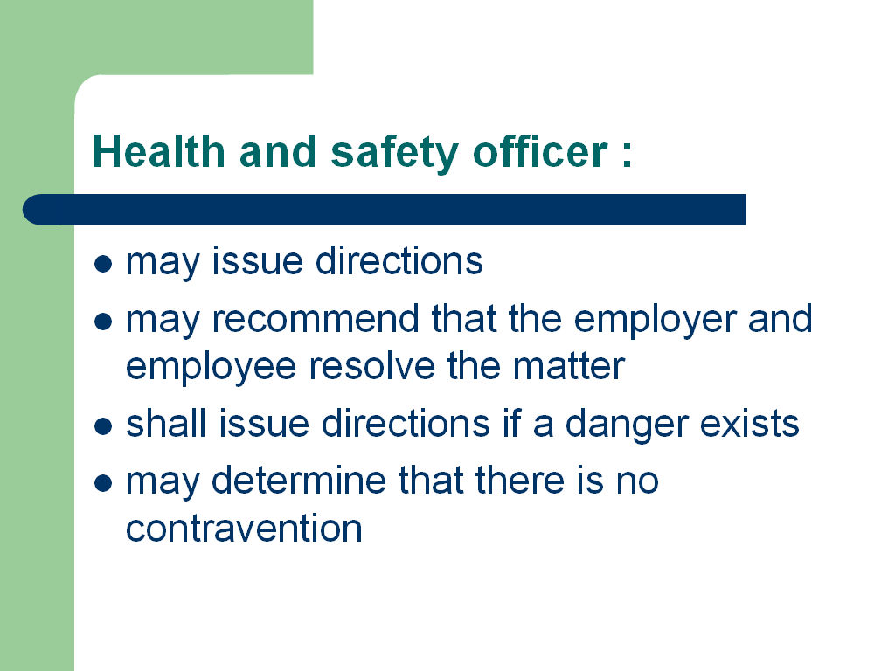 | HOW THE PROCESS WORKS  The specific process, which can be found in section 127.1 of the Canada Labour Code, is summarized in the chart on the following page. Please note that an employee cannot be disciplined for exercising his or her rights under this section as long as the employee has acted in accordance with the Code.  This process starts when an employee reasonably believes that there is a contravention of the Code or that there is likely to be an accident or injury to health arising out of, linked with or occurring at work makes a complaint to the supervisor.  It then continues through the steps shown in the chart until it is resolved, one way or another.  FINDING OF DANGER:  If the persons who investigate the complaint conclude that a danger exists as described in subsection 128(1) of the code, the employer shall, on receipt of written notice, ensure that no employee may use or operate the machine or thing, work in the place or perform the activity that constituted the danger until the situation is rectified.
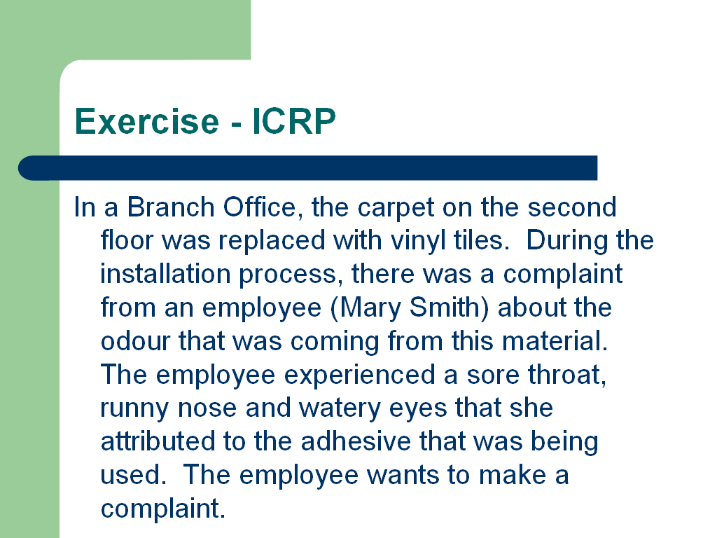 | Exercise  Note to Trainer:  This is a simple and quick exercise to confirm understanding of the ICRP  Internal Complaint Resolution Process (ICRP)  In a Branch Office, the carpet on the second floor was replaced with vinyl tiles. During the installation process, there was a complaint from an employee (Mary Smith) about the odour that was coming from this material. The employee experienced a sore throat, runny nose and watery eyes that she attributed to the adhesive that was being used. The employee wants to make a complaint.  In class, illustrate the internal complaint resolution process for that employee.

INTERNAL COMPLAINT RESOLUTION PROCESS
Where an employee believes there has been a contravention of Part II or that there is a likelihood of a work place accident or injury taking place:

STEPS | RESPONSIBLE | PROCEDURE
1 | Employee | Makes a complaint to their supervisor
2 | Employer and Employee | Shall try to resolve the complaint between them as soon as possible.  If it is fixed, no further action is required.
3 | Employer or Employee | If it is not resolved, may refer to a chairperson of the work place committee or to the health and safety representative
4 | Chair of the work place committee  or  Health and safety representative | In accordance with the committee’s terms of reference, shall cause an investigation team to be formed of an employee member and an employer member of the work place committee.  Investigates with a person designated by the employer  b)
5 | Investigating team | $ Will inform employer and employee of the results of their investigation  $ May make recommendations to the employer whether or not complaint is justified
6 | Employer | $ If complaint is justified, shall inform investigating team, in writing and without delay, of how and when the matter will be resolved  $ If investigating team concludes there is a danger, shall ensure no employee is subjected to the danger and must rectify the situation
7 | Employer or employee | May refer a complaint to a health and safety officer if:  - employer does not agree with the findings of the investigating team,  - employer has failed to inform the investigating team of how and when the matter will be resolved,  - the employer fails to take the necessary action, or  - the investigating team cannot agree on whether or not the complaint is justified
8 | Health and safety officer | Will investigate and on completion of the investigation:  - may issue directions to the employer or employee if a contravention is identified  - may recommend that the employer and employee resolve the matter between themselves  - shall issue directions if it is determined a danger exists  - may determine that there is no contravention.

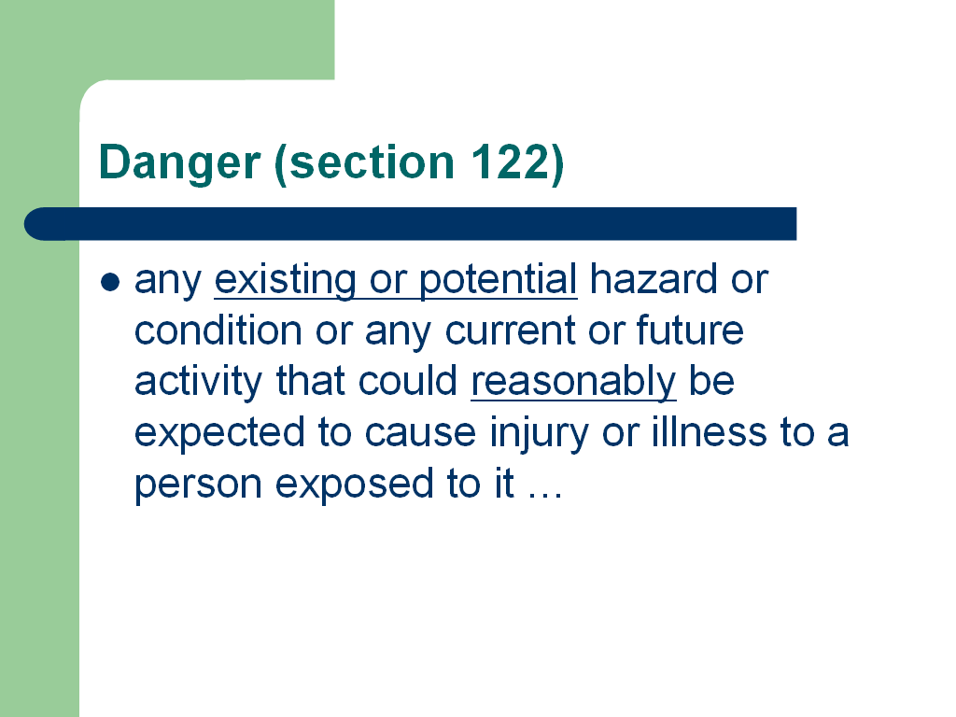 | 2. REFUSAL TO WORK  DEFINITIONS  The definition of “danger” as found in Section 122 of the Canada Labour Code reads as follows:  "danger" means any existing or potential hazard or condition or any current or future activity that could reasonably be expected to cause injury or illness to a person exposed to it before the hazard or condition can be corrected, or the activity altered, whether or not the injury or illness occurs immediately after the exposure to the hazard, condition or activity, and includes any exposure to a hazardous substance that is likely to result in a chronic illness, in disease or in damage to the reproductive system;
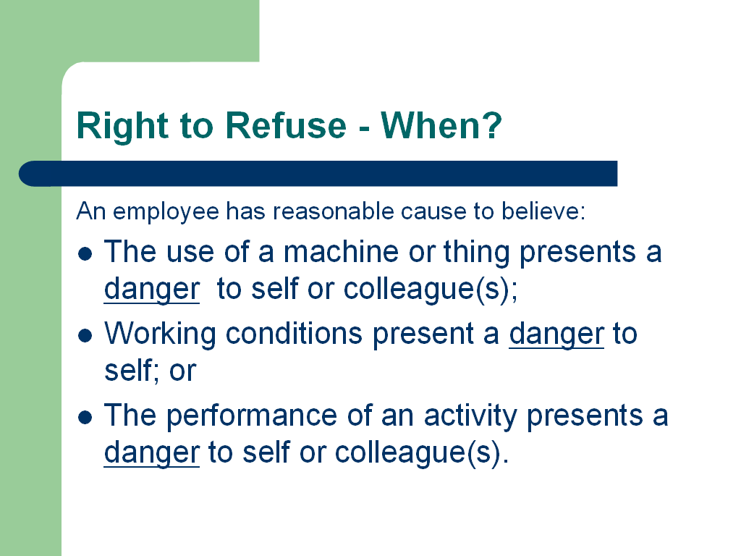 | 2.2 THE RIGHT TO REFUSE DANGEROUS WORK  Among the three basic employee rights which include right to know and right to participate, is the right to refuse dangerous work. These rights are embodied in OHS legislation and each employee in the Public Service has the legal right to exercise these rights without penalty.  Where an employee while at work, has reasonable cause to believe that:  - the use of a machine or thing presents a danger to that employee or his or her colleague(s);  - a condition exists at work that presents a danger to himself or herself; or  - the performance of the activity constitutes a danger to himself or herself or his or her colleague(s),  then that employee has the right to refuse to work as long as proper procedures are followed.
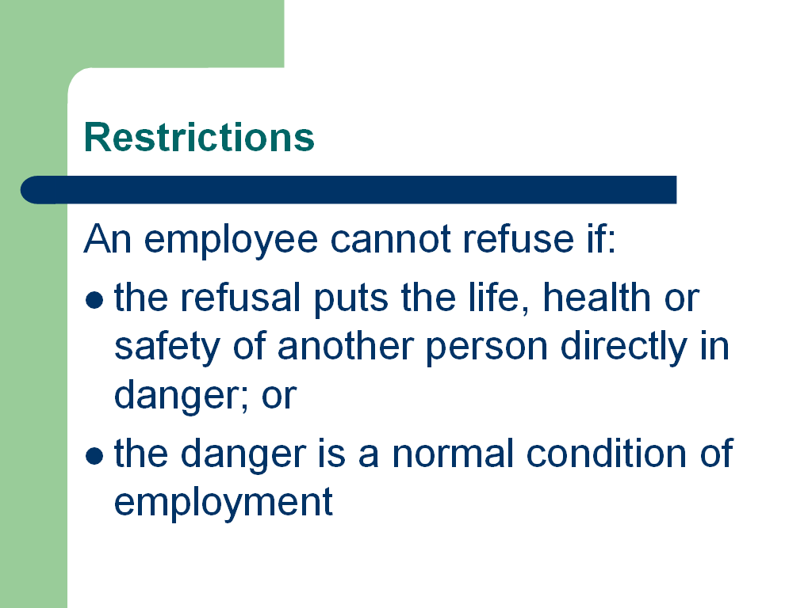  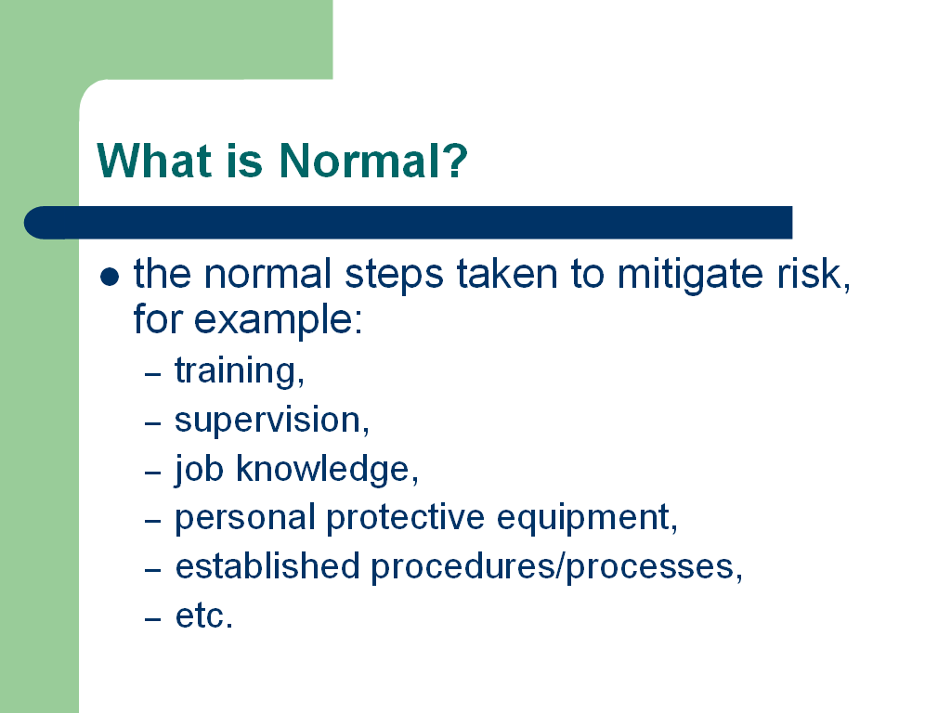 | - Restrictions  An employee cannot refuse to work if:  - the refusal puts the life, health or safety of another person directly in danger; or  - the danger is a normal condition of employment.  Note to Trainer:  Get input from participants as to what may constitute normal before putting up next slide.  Characteristics of Normal Condition of Employment  These are the normal conditions / circumstances under which the task is performed, including the normal steps taken to mitigate the risk (e.g. training, supervision, job knowledge, personal protective equipment, established procedures/processes, etc.)
Special cases for employees aboard ships or aircraft in operation
Employee reports the matter to the person in charge of the vessel or aircraft who, as soon as possible, will decide whether to allow the refusal. If the refusal is not allowed, the matter can be dealt with when the ship or aircraft arrives at its first destination in Canada. Employee may then exercise the right to refuse work.

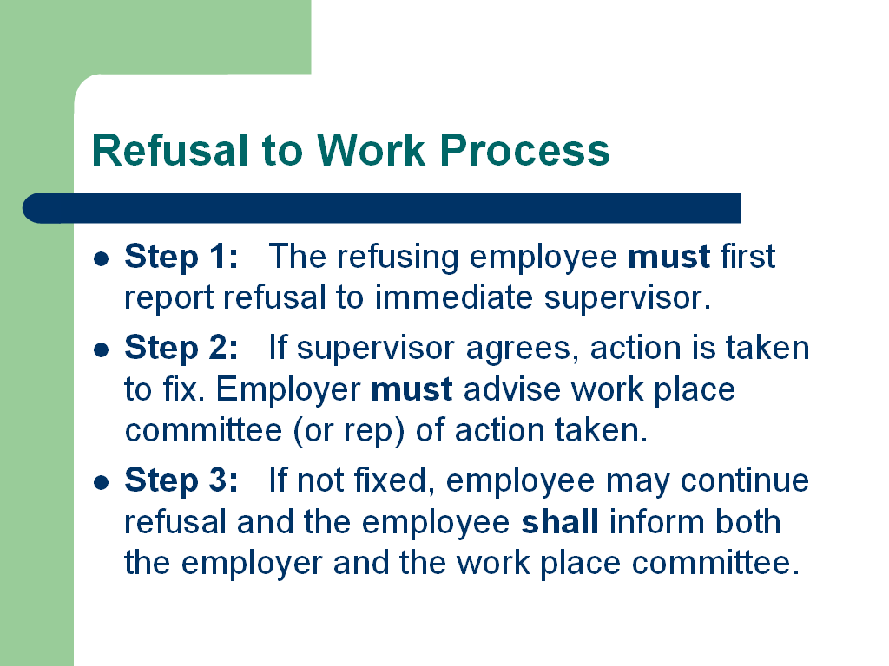 | It is important to note that these procedures require the involvement of a member of the local work place committee (or representative), normally from the employee representative side.  Step 1: The refusing employee must first report his or her refusal to the immediate supervisor.  Step 2: If the supervisor agrees there is a danger, immediate action will be taken to remedy the situation. The employer must then advise the work place committee or representative of the matter and the action taken to resolve it.
 | Step 3: If the matter is not resolved, the employee may continue the refusal and the employee shall inform both the employer and the work place committee.
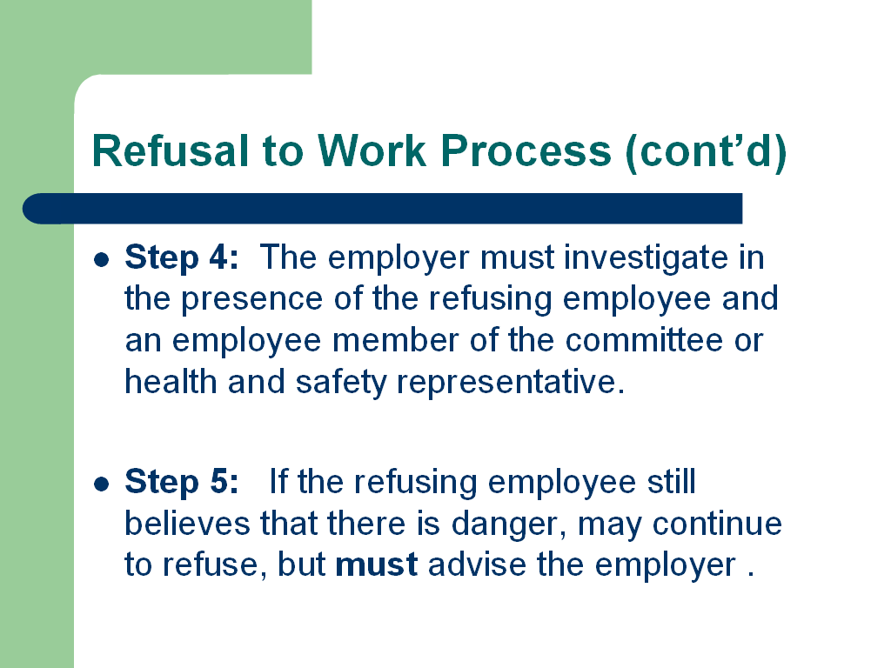 | Step 4: The employer must investigate the circumstances surrounding the refusal in the presence of the refusing employee and an employee member of the committee or health and safety representative. The presence of the committee member (or representative) is not only important, it is legally required. The committee member (or representative) provides useful third party input that may help in determining whether or not continuing refusal is necessary.  Following Step 4, should corrective action or other steps be taken to satisfy the refusing employee, that is to say, that the employee no longer believes that danger exists to his or her health or to that of a colleague - the refusal to work process ends
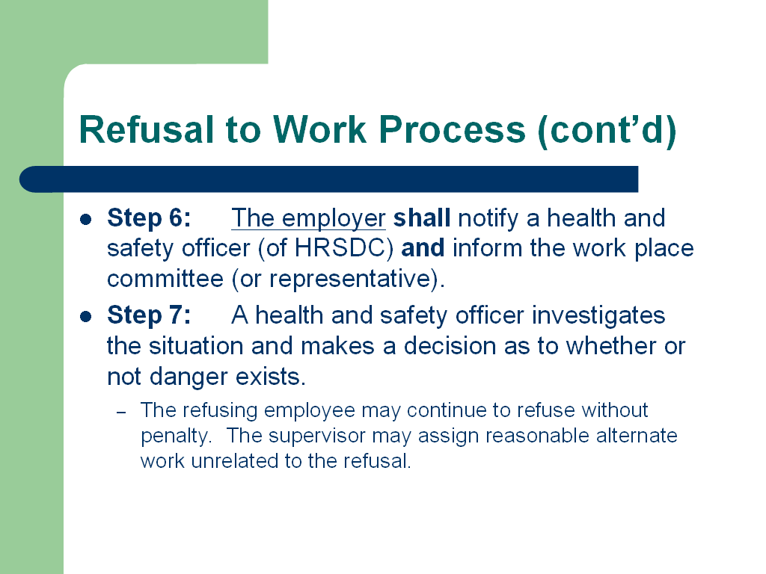 | Step 5: Should the refusing employee still believes that there is danger to his or her health or to that of a colleague or colleagues, that employee may continue to exercise the right to refuse.  Step 6: The employer shall notify a health and safety officer and inform the work place committee (or representative).  Step 7: At this point, a health and safety officer authorized under Part II of the Canada Labour Code formally investigates the situation and makes a decision as to whether or not danger exists. During the investigation, the refusing employee may continue to refuse without penalty. However, the supervisor may assign the employee reasonable alternate work unrelated to the refusal.
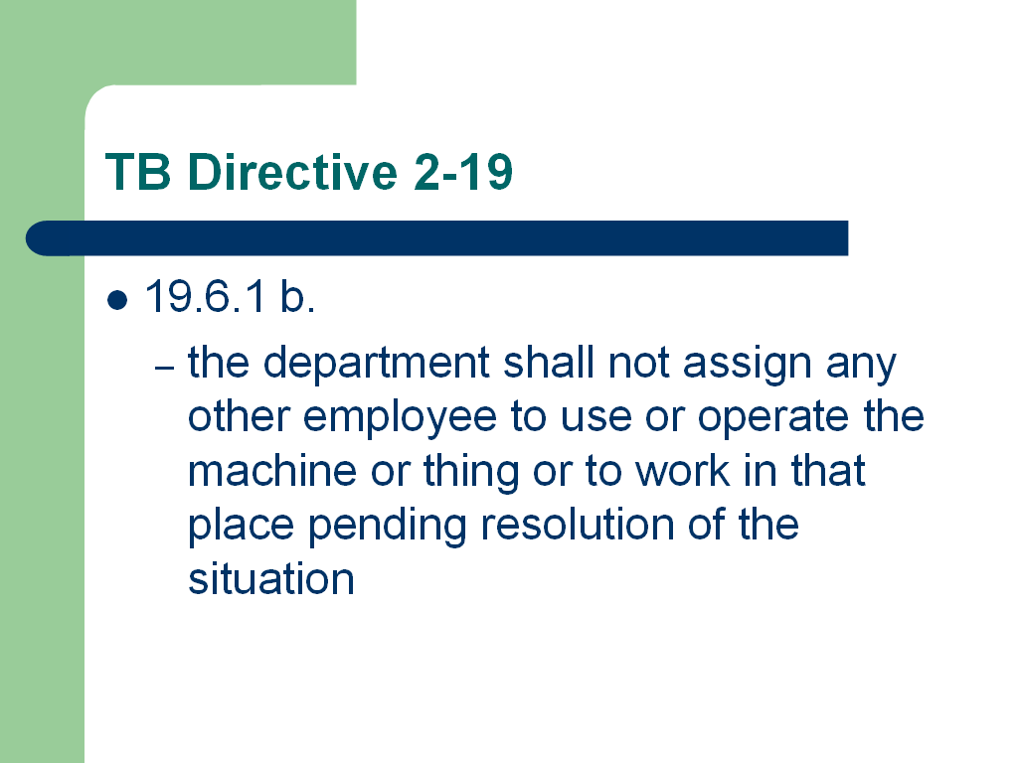 | FYI  Part II of the Canada Labour Code provides for the supervisor or manager to request that another employee perform the same duties, or work under the same conditions that resulted in the refusal to work, as long as that employee is fully informed of the circumstances of the refusal beforehand.  However, Treasury Board Directive (TB DIR 2 -19) - Refusal to Work does not allow for replacement workers prior to the investigation and decision of a health and safety officer.  It is the responsibility of the HRSDC health and safety officer to make a decision as to whether or not danger exists. If the decision is that there is “no danger”, the refusing employee must return to work. If the employee disagrees with the decision, then the employee, or a person designated by the employee for the purpose, may appeal the decision, in writing, to an appeals officer within ten days after receiving notice of the decision.  If the health and safety officer decides that there is a danger, then he would issue a direction to the employer involved to correct the hazard. Until such time as the hazard is corrected in accordance with the directive, the refusing employee is fully entitled to continue refusing without penalty.
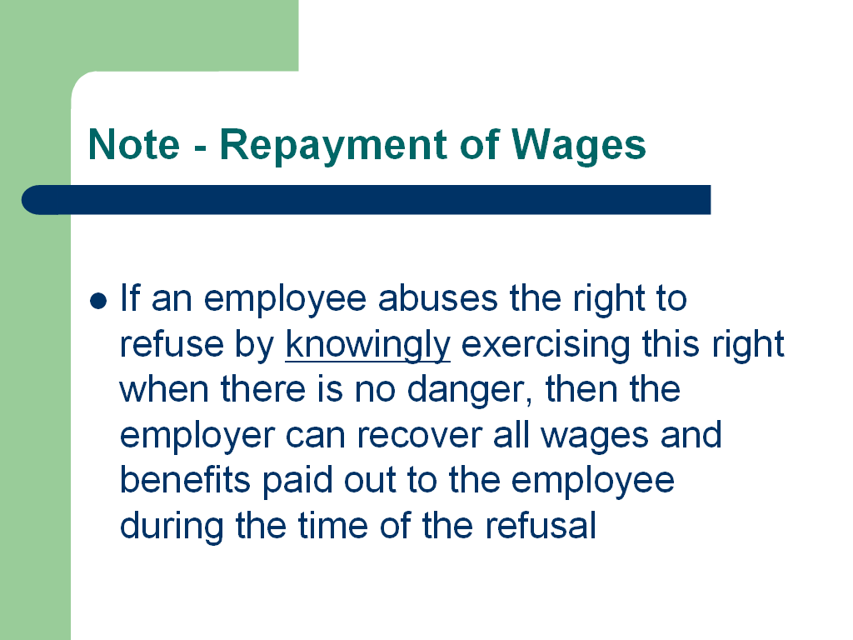 | 2.3 SPECIAL NOTE – REPAYMENT  From section 128.1 (4) of the code:  Unless otherwise provided in a collective agreement or other agreement, employees who are paid wages or benefits may be required by the employer to repay those wages and benefits if it is determined, after all avenues of redress have been exhausted by the employee, that the employee exercised those rights knowing that no circumstances existed that would warrant it.  What this means is that if an employee abuses the right to refuse by knowingly exercising this right when there is no danger, then the employer can recover all wages and benefits paid out to the employee during the time of the refusal

.
REFUSAL TO WORK PROCESS
Where an employee while at work has reasonable cause to believe that:
- the use of a machine or thing presents a danger to that employee or his or her colleague(s);
- a condition exists at work that presents a danger to himself or herself, OR
- the performance of the activity constitutes a danger to himself or herself or his or her colleague(s)

STEPS | RESPONSIBLE | PROCEDURE
1 | Employee | Advises their supervisor that they are refusing to work
2 | Employer | Shall try to resolve the complaint as soon as possible.  If resolved, the employer shall advise the work place committee or representative of the refusal and the measures taken to resolve it.
3 | Employee | If the employee still perceives a danger, he or she shall advise both the employer and work place committee or representative
4 | Employer | Must immediately investigate in the presence of the employee, a non-management work place committee member, a health and safety representative, or, if neither are available, a person from the workplace selected by the employee
5 | Employee | If the employee has reasonable cause to believe that the danger continues to exist, the employee may continue to refuse and must immediately advise the employer.
6 | Employer | Must notify a health and safety officer, as well as the work place committee or representative.
7 | Health and safety officer | Will investigate in the presence of the employer, the employee and a non-management work place committee member, a health and safety representative, or, if neither are available, a person from the workplace selected by the employee.  On completion of the investigation:  - shall issue directions if it is determined a danger exists.  - may determine that there is no danger.
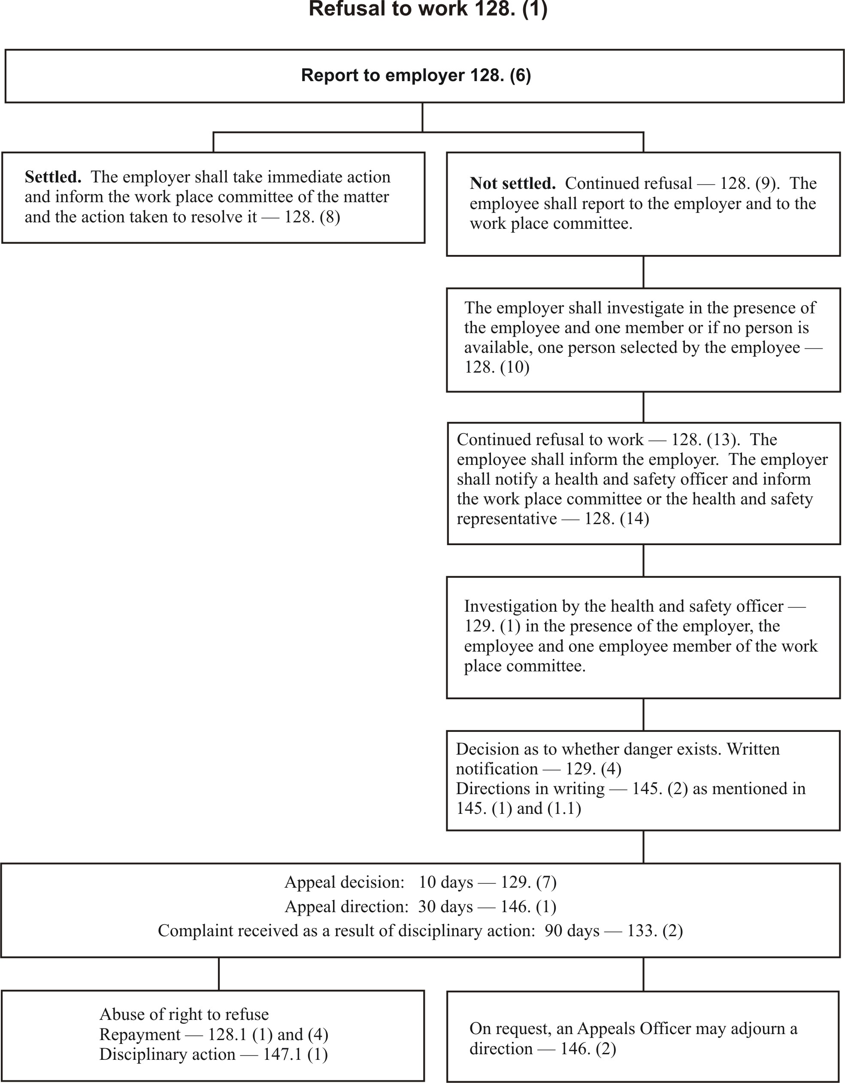

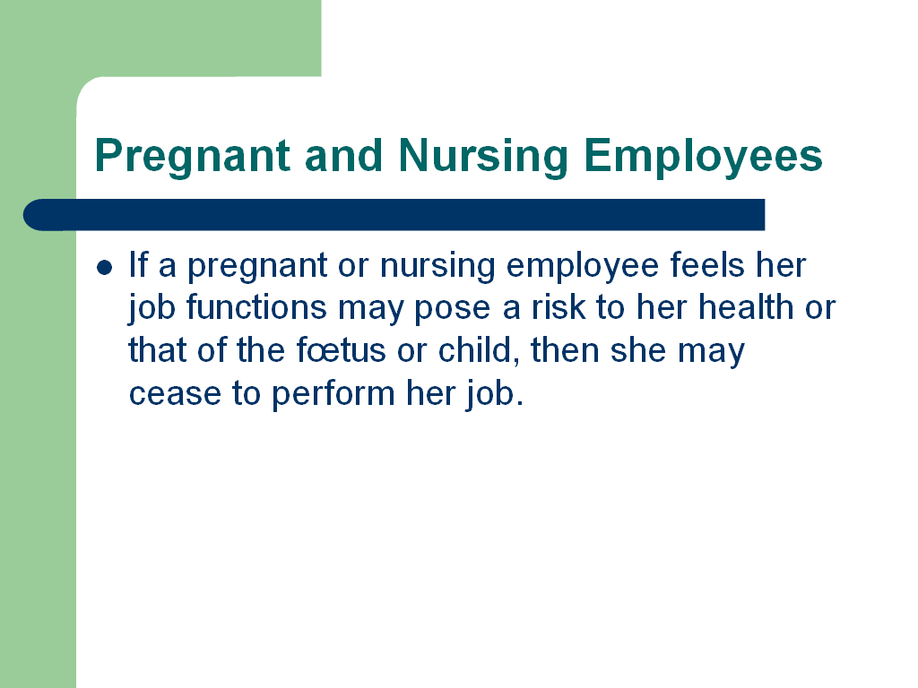  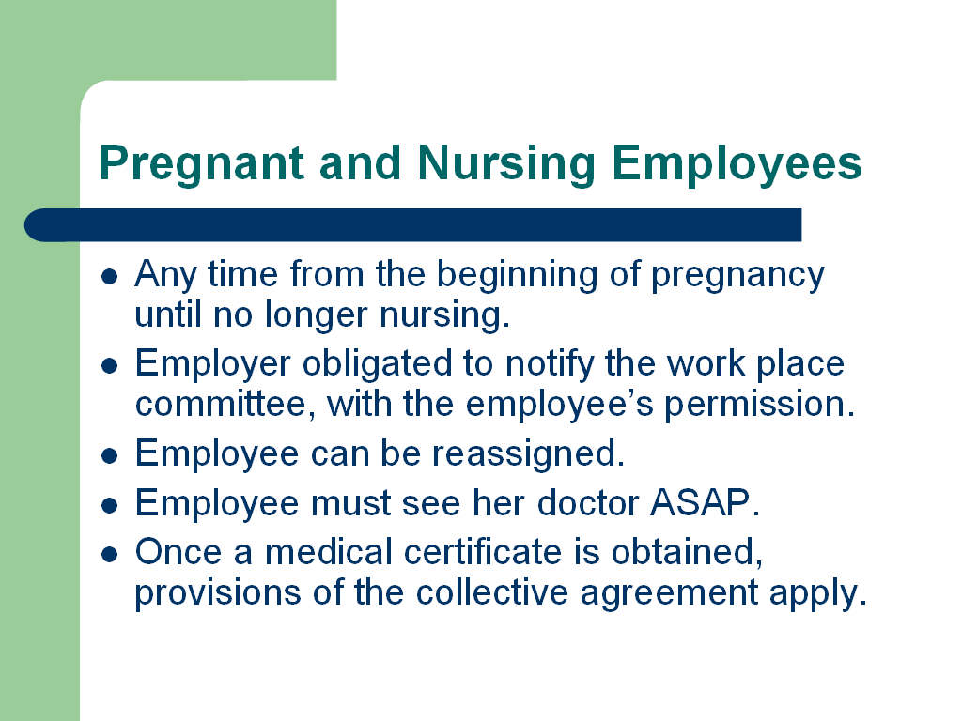 | PREGNANT AND NURSING EMPLOYEES  In addition to the right to refuse dangerous work (Section 128), an employee who is pregnant or nursing may cease to perform her job if she feels that, by reason of the pregnancy or nursing, her job functions may pose a risk to her health or that of the fœtus or child.  - This right may be exercised any time from the beginning of pregnancy until the employee is no longer nursing.  - The employer is obligated to notify the work place committee, with the employee’s permission.  - The employee can be reassigned at the same pay and benefits. If the employee cannot be reassigned, she is entitled to leave with pay until she can see her doctor.  - The employee is obligated to see her doctor and obtain a medical certificate as soon as possible.  - Once a medical certificate is obtained, provisions of the collective agreement apply.

4. REFERENCES & ACKNOWLEDGEMENTS:

The information in this module has been drawn from the following information sources / publications:

- EC - Environment Canada Health & Safety Committee and Representative Training – Session 3
- PWGSC - Workplace Committee Members and Representatives Training - Session 3
- CLC part II
- HRSDC – Labour Programme Operations Program Directives (OPDs) for Occupational Health and Safety

